Voice is often a better user interface which is much more natural for all of us. Amazon Alexa provides voice enabled services on top of IBM Watson’s rich Cognitive capabilities.

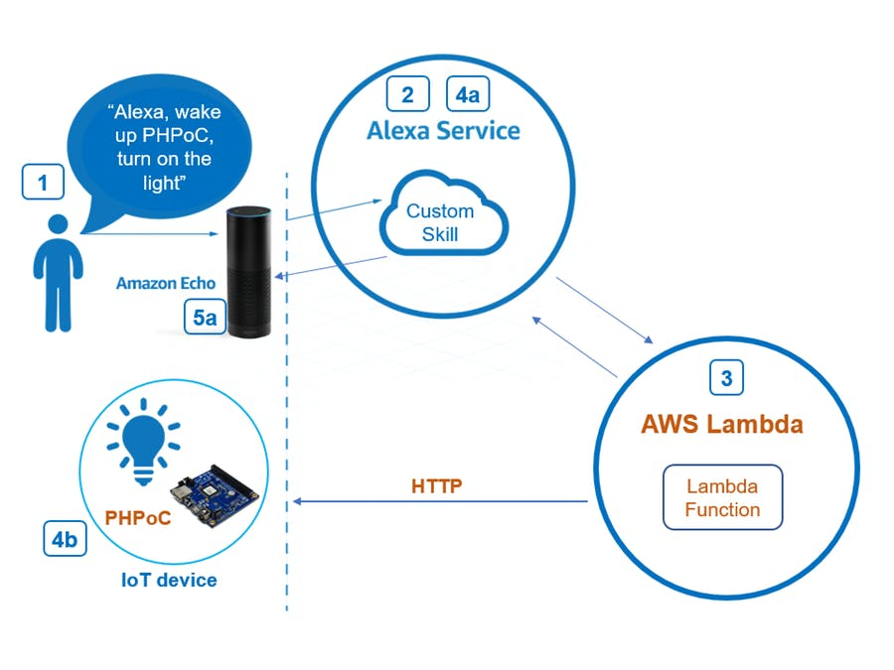

Things used in this project

Hardware components
- Amazon Alexa Echo Dot

Software Component
- Amazon Alexa Skills Kit
- Amazon Web Services AWS Lambda

Story
The Amazon Echo is a revolutionary voice-activated interface bringing together a powerful set of capabilities such as voice-recognition, Bluetooth speaker, streaming device, cloud connectivity and wireless access to Wi-Fi.
Watson Developer Cloud provides developers easy access to various Natural Language Processing building blocks including Conversation, Natural language Understanding, Personality Insights, Tone Analyzer. Each service provides REST APIs including various SDKs like Node, .Net, Java, Python.

Demonstration

XXXXXXXXXXXXXXXXXX
XXXXXXXXXXXXXXXXXX
XXXXXXXXXXXXXXXXXX

The big picture of this article
I. System Architecture
- 1. System diagram
- 2. Functionalities of each part and interaction among the system parts.
- 3. Which parts in system are changeable. If possible, which are the alternative
II. Amazon Echo Dot – PHPoC
- Step 1: Setting up an Amazon Echo or Echo Dot
- Step 2: Creating and configuring Alexa Skill (on Alexa Service)
- Step 3: Writing source code to handle requests Sent by Alexa (on AWS Lambda)
- Step 4: Writing source code on PHPoC to handle commands and control the devices
Now, let’s go into detail.

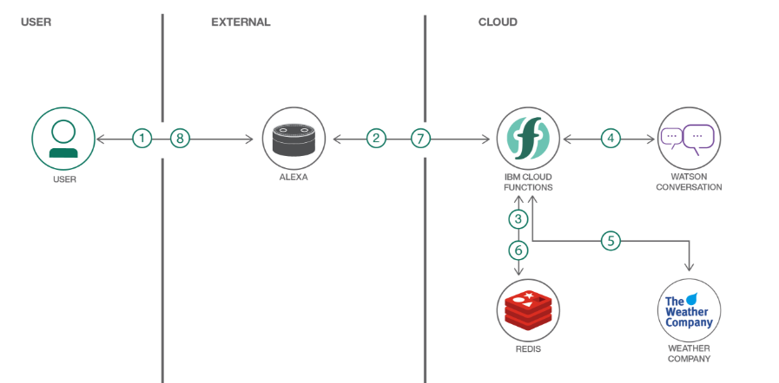
Amazon Echo or Dot receives data from the user through Alexa asking questions and prompting
These requests are handled by a function hosted on Amazon Web Services’ (AWS) Lambda
The AWS code handles requests/information based on invocation phrases
The data is then consolidated and routed to Watson Developer Cloud APIs through a set of orchestration services
This can also be integrated with enterprise data repositories to enable a better context

Reference
- Creating Alexa Skills with Ibm Watson”, https://dzone.com/articles/creating-alexa-skills-with-ibm-watson-presentation
- Amazon Alexa integration with IBM Watson, https://nexright.com/2017/08/amazon-alexa-integration-ibm-watson/

